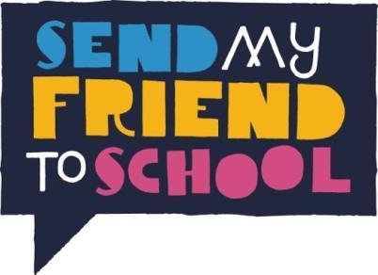
Apply now to be a 2022 Campaign Champion!

Applications must be made jointly by two students and one teacher and emailed to Nada.Mounzer@sendmyfriend.org by the end of the day on 16th December 2022.

If you have never taken part before, we really encourage you to reach out to Nada for a conversation about the project.

Interviews will be held over zoom the w/c 9th January 2023: both applicants and their teacher will need to attend

The Send My Friend to School campaign values diversity, equality and inclusion for persons working for and on behalf of the campaign. We strongly encourage applications from young people of any gender, disabled young people and young people of diverse cultural, ethnic, socio-economic and other distinctive backgrounds. If you need any additional support to complete the application form or attend the training, then please do get in touch.

Name, Address & Phone Number of School
Name of Applicant 1 (teacher)
Name & DOB of Applicant 2 (student)
Name & DOB of Applicant 3 (student)
Please indicate if any of the applicants have a disability and/ or accessibility requirements?
Please indicate if either/ both of the students receive pupil premium and/or SEN support?

Tell us a little bit about yourselves. What qualities or skills would you bring to the campaign? (max 150 words per applicant)

Please answer the following questions jointly:

Why do you want to be a Send My Friend to School Campaign Champion? (max 200 words)

Why is it important to you to be involved in campaigning to ensure that all children across the world get a quality education? (max 200 words)

How would you encourage your school and wider community to get involved in the Send My Friend campaign? (max 200 words)

At the end of the campaign champion programme what new skill/s would you like to have gained? (150 words)

Please sign to confirm your application meets the following requirements:
- This is the only application from your school.
- The two student applicants are in Year 9 or 10.
- This application is from a UK State school.
- If successful, applicants would be available for a video interview during w/c 9th January 2023
- If successful, applicants are able to attend a UK residential training in March/April 2023 (location tbc)
- If successful, applicants are able to attend a special event in parliament in June 2023
- If successful, applicants are committed to campaigning on education throughout 2022 including attending at least the residential training, one campaign engagement (e.g. Parliamentary Action day or Party Conference) and running at least one event in their school/community.
- Students should also be prepared to attend semi-regular catch up calls/ trainings where relevant, and contribute in additional ways such as writing blog posts, attending other events, and contributing to campaign ideas.
- Teachers will act as the main points of contact, and need to remain in regular contact with Send My Friend, as well as attending events to chaperone students to events.
- If successful, applicants will keep in regular contact with Send My Friend and respond to emails and phone calls promptly.

Signed by:
Applicant 1 | Applicant 2 | Applicant 3 (teacher)
I have read the above requirements for Campaign Champions and confirm that _____________________________ School supports this application.

Leadership team member (to give approval) :

Name:

Signature:

