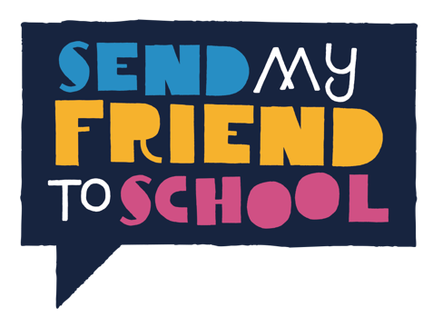
MP TOOLKIT

Meet your local MP!

After all your effort creating your paper hearts, it is time to make sure they get to your MP. A great way to do this is to invite your MP into school. Organising an MP visit is also a great chance for your students to learn about active citizenship, democracy and representation. MPs are used to receiving invitations to meet people in their constituencies and usually do their best to meet as many local people as they can. It’s their job! They won’t be surprised to be invited to your school, and may have visited already.

Before your meeting

Step 1 – Find MP’s contact details
It is best to contact your MP at their local consistency office. To find the address visit findyourmp.parliament.uk and enter your school’s postcode. This will provide you with information including your MP's name, contact details and website. Most MPs have their own websites that include their contact details and news about recent constituency activities.

However, a few MPs don't have a constituency address, in which case you should write to their parliamentary address: (Name of MP), House of Commons, London, SW1A 0AA.

Step 2 – Send your invitation
Now you have your MP’s contact details you can invite them to your school. Make your email or letter precise and brief. Explain that your students are involved in the Send My Friend to School campaign calling for the UK government to ensure all children have the Right Climate to Learn.

Suggest the time(s) and date(s) you’d like to meet. MPs are busy, so be prepared to be flexible about your plans. MPs are most likely to be in the constituency on Friday, but are unlikely to have enough time to spend more than one hour at your school - this is more than enough time to get your message across.

The Send My Friend Week of Action will be 15th – 19th June 2020 so it would great to meet your MP in this week if possible, but if that doesn’t suit then don’t worry, you can arrange to meet on another convenient day.

If you don’t hear back from your MP’s office, then give them a phone call - ask to speak with your MP’s ‘diary secretary’ and try to make sure they’ve seen your invitation and are acting on it. If your MP isn’t available to visit your school - don’t worry, this doesn’t mean you can’t make your voices heard. You could ask to visit them at their constituency office instead. If it is not possible to meet, then instead send your school’s paper hearts and messages through the post with a letter.

Step 3 - Preparing for your meeting
There's no need to be nervous! Your MP won’t expect you to be an expert and many MPs are not experts themselves. You simply need to let her or him know how passionate you and your students are about quality education for every child, and them to ensure that everyone has the Right Climate to Learn.

- Use your MP's website, or www.theyworkforyou.com to find out a little bit about them and what, if anything, they've said about global education and climate change.
- Plan what you are going to say and who is going to say it. You could divide your presentation into separate sections with pupils sharing out the roles.
- Rehearse - you could ask another teacher to play the role of your MP. Think about any props and visual aids you’re going to use.

During the meeting

Step 4 – Present the campaign

Explain that you and your students are part of the Send My Friend to School campaign, present your paper hearts, and try to get the main messages of the campaign:

- The climate is changing. It’s causing extreme weather events around the world and wreaking havoc on people’s hopes and lives, including the fundamental right to education.
- Having an education is central to facing and fighting climate change, yet world leaders are neglecting education as part of the global climate response.
- In 2020, the UK must sieze the opportunity to take action to reduce our contribution to climate change and ensure all children have the Right Climate to Learn.
Step 5 - Ask for something
Make sure you ask your MP to do something! The main thing we need MPs to do is pass on your paper hearts with a message of support to the Prime Minister calling for the UK to take bold action on global education and climate change.
Here are some additional ideas of what you could ask your MP to do:
- Tweet about the meeting and publicise their support for the campaign – ask them to include the @sendmyfriend handle.
- Join the All Party Parliamentary Group on Global Education (a group for MPs from different political parties who are keen to support this cause).
- Write a blog/article on their website about the campaign and what action they will take.
- Ask a parliamentary question about what the UK is doing to tackle climate change and global education.

Step 6 - Make an impression
Send My Friend to School provides lots of opportunities to get creative, so think about how to make a colourful impact to go alongside your paper hearts. You could really go to town with drama, music, film and photography. Use the most powerful and persuasive facts and arguments! However, remember anything you do should support a strong message and not overwhelm it, and keep in mind how much time you have available.

Step 7 - Record what happens
Choose someone to take notes of any comments or promises your MP makes, and someone to take photos of your meeting, particularly if you've organised something visual such as a display, handover or stunt. Photos will really help to spread the word about your event.Then you can share your image on Twitter remembering to include the @sendmyfriend handle, on your school website, and through local media too! See our Press Pack for more tips.

After the meeting

Step 9 - Stay in touch
Write to your MP to say thank you for the meeting, and to remind her or him of any promises made during the meeting. Your MP may well post something on their own website or blog if they have one, so include copies of photos.

Track your MP’s actions by setting up an email alert from www.theyworkforyou.com/. Find out if she or he speaks in support of building the Right Climate to Learn for every child around the world. Aim to build a relationship with your MP and keep in touch with them.

Step 10 - Spread the word
Use one of the press release templates provided in our Press Pack and send it to your local newspaper, or any popular local news blogs, along with a photo of your meeting. This should be done within a few days of the meeting.

Don't forget to publicise the meeting in your school's newsletters, website etc., and make sure to use our online totaliser at Send My Friend totaliser to let us know how it went and share your photos and stories.

Good luck!

