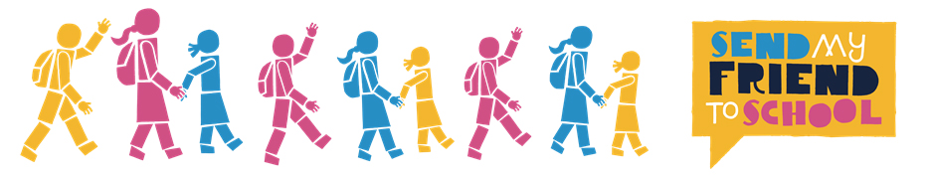
EMILY: Send My Friend to School highlights the importance of education for all. It’s a campaign to show important figures like MPs and other politicians how passionate young people in the UK feel about the right to education and demand that they do everything in their power to ensure that world leaders meet the education targets set by the previous Millennium Development Goals, and now the Sustainable Development Goals and provide every child with a quality education .
GEORGE: This campaign is necessary and effective. It’s active throughout 5,000 UK schools to educate our nation’s children on the right that they have to education , and the way in which millions of others around the world - just like them - aren’t receiving this basic human right. Every year around half a million young people take part in lessons and activities. They then do a creative action which are sent in their tens of thousands to constituency offices up and down the country and eventually to No.10. This year pupils are making paper rucksacks to symbollize the journeys taken by children who are forced to flee their homes and schools as a result of an emergency. The campaign actively engages pupils in campaigning and educates them on the issue.
EMILY: It’s outrageous that in 2016 there are still millions of children who are denied their human right of quality education. The Send My Friend to School campaign is important because the need for global education is frequently an issue that gets overlooked, or brushed under the carpet, especially in richer countries like ours. This campaign puts pressure on our leaders to discuss this vital issue. It makes the topic of education an unavoidable issue, and an issue that must be dealt with.
GEORGE: Of the millions out of school, a huge proportion of them are from countries affected by emergencies such as Nepal where 1 million children were forced out of school by the terrible earthquake last year. We hear daily about the perilous and saddening situations that refugees face in their daily lives , yet we often forget this results in a loss of education. Without an education , refugees are taken away from the normality of life , and are left with insufficient skills when they are rightfully settled in a safer country. Not only this , but a lack of education halts them from restoring peace to their countries.
EMILY: Syria is an obvious example of where children in conflict areas aren’t able to go to school. Being forced to flee their homes and schools strips them of their freedom and safety, and we need to change this. The children in these conflict areas, need some sort of consistency in their lives, and if it can’t be their home, then it should be school. And in northern Nigeria the violence from Boko Haram has displaced 1.4 million children from their homes and destroyed 900 schools. Although massive strides have been made since 2000 when the MDGS were set unless education in emergencies is addressed, and more aid provided, this progress will go backwards.
GEORGE: This affects all genders massively , but girls are missing out more, that’s why today’s focus is on Girls’ Education. Coming from war or disaster stricken countries , girl refugees are vulnerable. A school provides them not only with an education , but with a caring community and a safe place to go. A place where a young girl needn’t worry about being attacked. An education is pivotal not only for the futures of these girls , but for their immediate safety too.
EMILY: During our visit to Ghana, we furthered our knowledge about this campaign and why it’s important. I met Lariba who’s widowed mother couldn’t afford to send her to school. She spent her days helping her mother to collect cow dung which they sold as fertiliser. Although she wasn’t living in an emergency I could see how little hope she had of changing her life without an education. From this, my thoughts are that if you can campaign on behalf of other people that are suffering- you should. There’s a difference between dwelling on issues, and actively trying to destroy the cycle. I’ve realised that a world where millions of children can’t go to school should be a thing of the past or a collection of facts in our history books. But unfortunately it’s not history, it’s happening. This should be enough to drive all of us to campaign for a world where every single last child can go to school and learn.
GEORGE: Although Ghana is not war torn, or suffering from a natural disaster, what we saw in the remote northeast, which we visited, was that poverty was widespread and extreme. One thing that clearly prevailed was that educating young girls led to their empowerment and a greater confidence within themselves. We met a Girls Club run by ActionAid and were inspired by their energy and determination. They went around the village convincing parents to send their girls to school, and the parents listened to them. If we invest more money and resources into girls’ education , it’s obvious to me that not only will we be helping them directly , but they themselves will go on to make the real and lasting changes within their communities.

