Young Ambassadors’ diary from Uganda
Maisie le Masurier and Rebecca Unwin are the 2014 Young Ambassadors for the Send My Friend to School campaign. They have just returned from visiting Uganda with the charity Sightsavers and the Global Campaign for Education.
In Uganda 22% of primary aged children are not in school, and a high proportion of the population suffer from disabilities, which can lead to a chronic cycle of poverty. Children with disabilities face the greatest obstacles to getting a quality education. Maisie and Rebecca met some of these children and also saw some of the steps being taken towards delivering quality education for all…
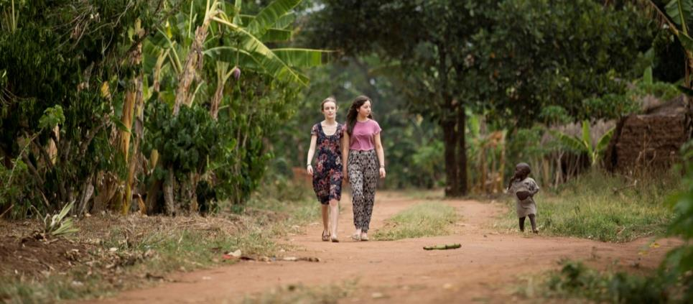

Rebecca and Maisie in rural Iganga
Day 1: Arriving in Kampala
After a long journey we arrived in Uganda, greeted by sunshine. Driving to the hotel we bolted down the chaotic roads of Kampala and got a glimpse of Ugandan culture and way of life.
Upon arrival we met Juliet, the Sightsavers Uganda Education Programme Officer, who made us feel extremely welcome and gave us some background.
Juliet explained the Ugandan schools system and some of Sightsavers recent achievements. These include lobbying the government to change their early child education policy to be inclusive of disabled children.
We heard that there is a huge shortage of teachers in general, the classes are far too large, and most teachers aren’t trained to teach special needs.
Maisie and Rebecca in a meeting

Learning about special needs education
Special Needs teaching is not seen as a good job, and there is often a stigma attached to it. Teachers aren’t paid well and there is certainly no reward for the extra work required. And worse still, there is a strong feeling amongst many people that children with disabilities aren’t worth educating. Itinerant teachers – who travel around to teach – are needed to find those children currently not going to school, and to work with schools to make sure children with disabilities are welcomed.
Sightsavers are currently campaigning for a policy to be agreed in parliament to increase the pay of special needs teachers, thereby attracting more teachers, reducing teacher-pupil ratios and facilitating greater access to education for more children.
It was a very helpful and informative meeting; we left feeling really excited about what was to come!
We also enjoyed our first meal in Uganda – an African chicken dish….delicious!

Day 2: Hearing about advocacy work in Uganda
Today we met with advocacy organisations to hear more about the barriers preventing some children with disabilities from going to school. First we met with James, from Uganda National Association of Teachers Union (UNATU). Among other things, UNATU aim to improve the quality of public education and advocate for learning and social development. He told us many more teachers were needed, to the tune of 50-60,000. James also talked to us about the common classroom complications in Uganda, which make teaching very difficult, including large classes, lack of basic facilities, demoralised teachers and inaccessibility for children with disabilities.
We also visited Fred, a kind and helpful representative of the Forum for Education NGOs in Uganda (FENU) – a member of the Global Campaign for Education. Fred told us about the chasm between policy and practice. Promises are made regarding improvements to the education system for children with special needs but often fail to materialize.
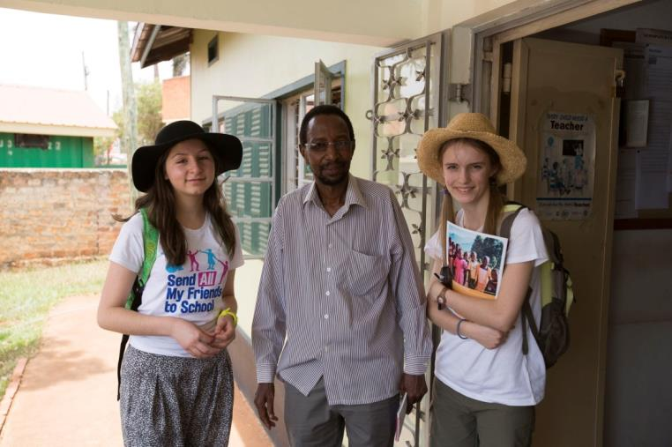
Rebecca and Maisie with Fred from FENU

We were surprised to learn from Fred just how small the budget for education is in Uganda. Previously, 17% of the Government’s money was allocated to education, but this figure has now fallen to 14%. Worse still, only a tiny proportion of the education budget goes to special needs. The sad thing is that, in reality, even this small amount of money rarely reaches the children that need it.
Fred believes that there are a few fundamental factors in securing a brighter future and better education for the new generations of Uganda, including more inclusive and participatory teacher training, and more government supervision and inspection of schools to guarantee that policy is put into practice in the education system.
Meeting inspiring young campaigners
We also met 3 visually impaired young campaigners from Uganda National Association for the Blind. We were very inspired by the great campaigning they are doing in Uganda. They told us that generally it is very hard for a child with a disability to get an education, partly because many come from poor families who cannot provide the extra fees or materials needed – it costs 300 shillings (7 pence) for a pencil and paper but 2 million shillings (£500) for a Braille machine. Their campaigning aims to change negative attitudes towards people with disabilities, and to give young people a voice so they have a say in their own education. They run radio programmes, leadership training and encourage students to start local associations, educating them on their rights and how to attain them.
Maggie, who was always smiling, told us that she had met a boy who was unable to take his exam that he had worked hard for, simply because he could not afford the exam fees. Maggie helped him convince the teacher to let him pay the fee later. He is now at University. Maggie is a great demonstration of someone who did not let their disability hold them back, and, not only worked hard for her own future, but for the future of others, too.
Again and again throughout the day we heard the same obstacles for disabled children: lack of special schools; long distances to existing schools; school fees; lack of equipment, materials and facilities; and a lack of trained special needs teachers.

Day 3 – Children out of school in rural Iganga

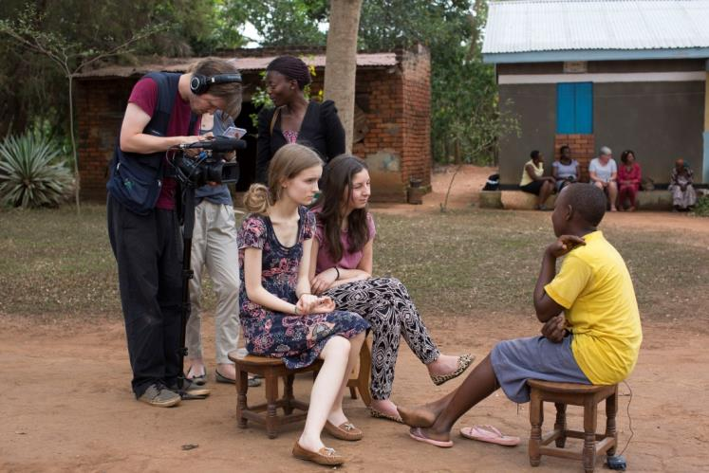
Rebecca and Maisie interviewing Eva

Today we went into rural Iganga to visit visually impaired children who do not go to school. We met a bubbly 16 year old, Eva. She showed us round her family’s home. It consisted of 2 small rooms without lighting or electricity, with concrete walls and floors. Despite Eva’s family house being basic, they took pride in their home; Eva’s bed was beautifully embroidered and, unlike some in Uganda, she had it to herself. She told us that she had to drop out of school when she was 13, after the pain in her eyes affected her vision, and the school was unable to help her. She wanted to be a doctor, but has had to give up this ambition due to her incomplete education and failing eye-sight. Eva’s future appears bleaker than it should be - she knows there are few options for a poorly-educated, visually impaired child.
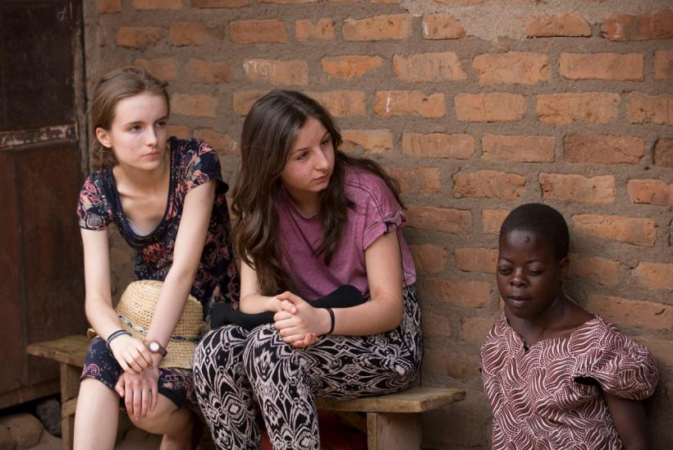
Rebecca and Maisie with Nabirye

When we arrived to visit Nabirye there were a number of children, mostly in flamboyant pink and orange school uniforms, all gathered around. They were all initially shy but within minutes they were chatting to us, making us laugh and giving us high fives.
It was incredibly eye-opening to see the harsh divide between these happy children who receive an education, playing with their school friends, and then to look just a metre away and see Nabirye, huddled on the floor barely raising a smile.
Nabirye, now aged 15, told us that she had to drop out of school when she was 10 because she couldn’t see the chalkboard and, like Eva, her school was unable to help children with visual impairments. Nabirye told us how isolated she felt, but thought if she went to a school where other pupils had disabilities she wouldn’t feel like this and would get better support.
Unfortunately, there are no schools like that nearby and her family cannot afford for her to go to a boarding school. We were saddened by our conversation with Nabirye, and left feeling helpless.

Dreaming of going to school
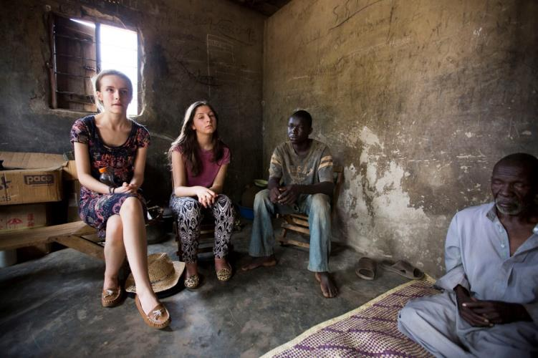
Rebecca and Maisie in Hamza’s home

17-year-old Hamza is blind – as is his father who struggles to support the family. Hamza’s family cannot afford the fees at schools that are equipped for visually impaired children. He told us how lonely he was, as all his friends headed off to school and he sat on the same chair all day, every day, hoping that one morning he’ll wake and be told he can go to school.
The last person we met was 16-year-old Martha. Her school also didn’t help people with disabilities; Martha wasn’t learning so she left. Martha experienced prejudice and recalls being branded ‘the blind person’ and being left alone on a chair. It was hard to listen to Martha telling us that she sometimes gets laughed at, as her sight problems mean that she can stumble around a bit, trying to find her way. And that she is desperate to go to school, constantly thinking of the colossal improvement it would make to her future. She hasn’t lost her ambition though, telling us “If given hope I can become a teacher or a lawyer. I need to go back to school to do this.” So, we were thrilled to give Martha a Braille slate so that she could learn at home and not be too far behind if she does get to go to an inclusive school. She was delighted and clearly eager to get started.
Meeting these children today has been upsetting, but filled us with more motivation to help change the situation.

Day 4 – inclusive schools
Today we visited 2 schools in Iganga.
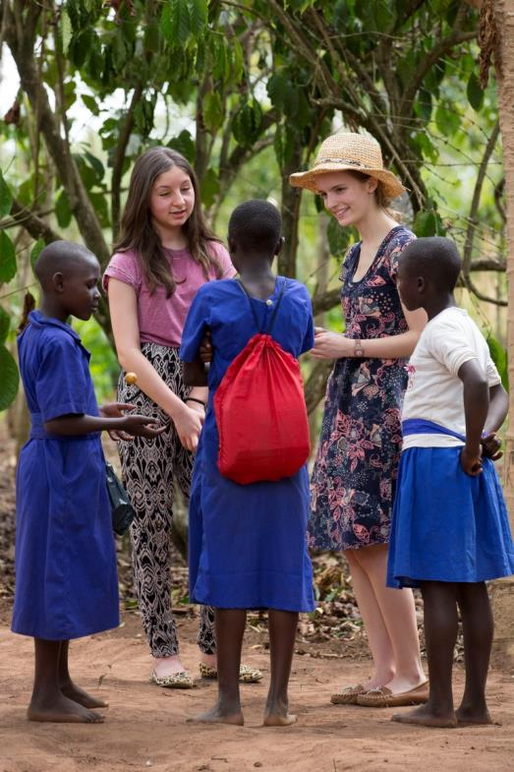
First, we visited the friendly Bishop Willis Primary School which is a great demonstration of inclusive education for children with visual impairments. 56 visually impaired students attended the school, and all of them participated in classes with sighted children - integrating with society. But, they also regularly visited the Visual Impairment Unit that provides for their individual needs, too. It successfully incorporated extra support and social blending for the visually impaired students. We watched a number of lessons, and all the children performed a welcoming song as we entered the classroom. The teachers in the Visual Impairment Unit were fantastic, and the pupils had a great trusting relationship with them. The materials the unit had were basic and minimal, with only 2 braille machines. But, we were heart-warmed by their positivity – making the best of the few things they did have and taking nothing for granted.

Speaking with children from Bishop Willis school

Children given the chances they deserve
We met a young boy called Peter who, despite not being able to see, Peter is happy - singing little melodies under his breath as he works. Peter’s teachers look beyond his disability and are investing in educating him.
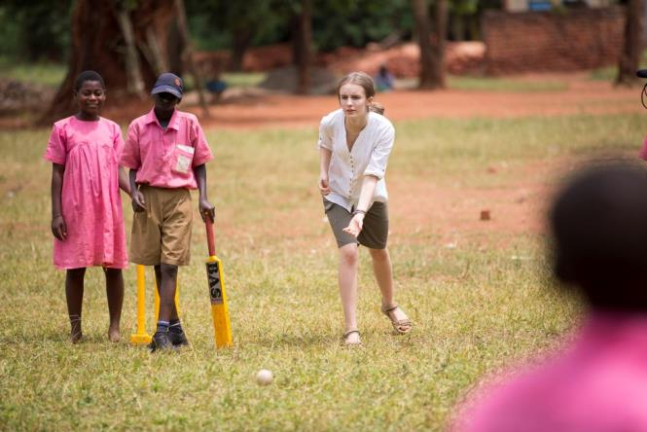
Playing cricket!

It was great fun playing cricket with them, using a ball that made a sound as it moved. As they batted and bowled it was clear that at Bishop Willis they were taught that a disability should never hold you back! It was an uplifting morning and we were left inspired and educated – and ashamed by our cricketing skills!
We felt the Iganga Secondary School was better equipped than the Primary School; the buildings were cleaner and painted, the edges of the paths were painted for the visually impaired, and there was a more advanced Visual Impairment Unit. This particular school was a private school for girls, but also accepted boys if they had any visual impairment.
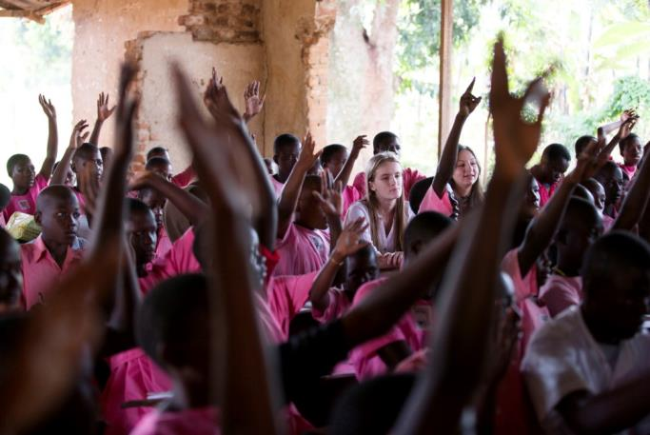
A class at Iganga Secondary School
First we entered a geography class where we stayed for a while, impressed by the enthusiastic teacher. The class was big and crowded, but very disciplined. We visited the Visual Impairment Unit and had a conversation with a 17 year-old boy named Joseph. Joseph’s ambition is to be a lawyer or a journalist, and he was determined to do well in his A Levels to be able to achieve this. Joseph is very short sighted, and has limited vision, and can only see shapes beyond a certain point. However, he made it clear to us that he would not let that stop him from trying his best to achieve the highest. He was confident and passionate, and a great inspiration to both of us. This experience made us see what Ugandan schools can achieve if given sufficient financial backing.
At both schools there were visually impaired teachers who taught all the children, and it was clear that they were great role models, offering counselling, sharing their own experiences and teaching life skills. Justin, a visually impaired teacher at Iganga secondary school said “I wish all blind people would be given the chance to go to school. They now live like any other sighted person. With education you can fit in society. Through Braille you can know everything in the world.”

Day 5 – meeting policy makers
On our last day we met Eseza Mirembe and Jane Kantono, ministers of the special needs department within the Ministry of Education and Sports. They were happy to answer our questions and we were impressed with their openness and honesty about the current situation regarding special needs education in Uganda.
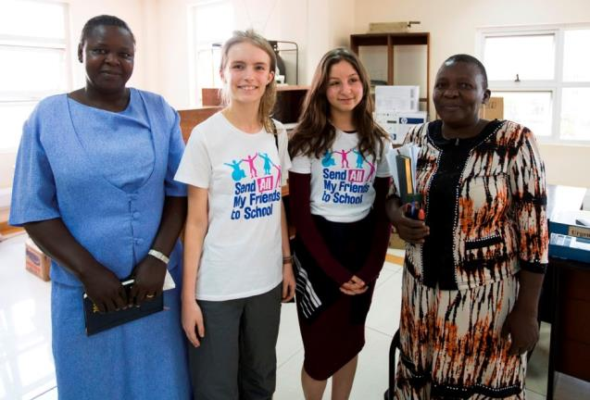
We found out that the department takes responsibility for children who have disabilities and other learning difficulties. It tries to provide teachers with equipment, materials and training on the job, such as knowledge of the Braille alphabet. Sightsavers and other organisations have been working with the department for years to train teachers for special needs.
They look at problems that prevent children from attending school, such as distance, money and poverty. They send out special needs representatives, but cannot afford do this everywhere.

Rebecca and Maisie at the Ministry of Education

One of the huge problems in special needs education is the lack of funding. Braille machines are very expensive, so cheaper things like Braille slates are used – but writing on Braille slates takes ages. There are many people in Uganda who can’t afford all the fees that are needed to ensure their children can get an education – such as exam costs, uniforms and learning materials. These problems are often much more extreme for children with disabilities since there is little extra provision to help them.
The ministry’s budget for education is small, and the money left for special needs is even smaller. But there is some hope, as a new inclusive and special needs policy is awaiting approval from the government.
Following our question on what part children could play to raise awareness of special needs in education, we found out that sports and music were important tools to help engage and educate children.

Changing attitudes
The attitude of everyone towards children with disabilities is perhaps the biggest challenge. We heard how the Ministry has to even encourage parents to send their disabled children to school. But inclusive schools bring children with and without disabilities together and help improve attitudes and remove stigma.

Back in the UK and time to think …
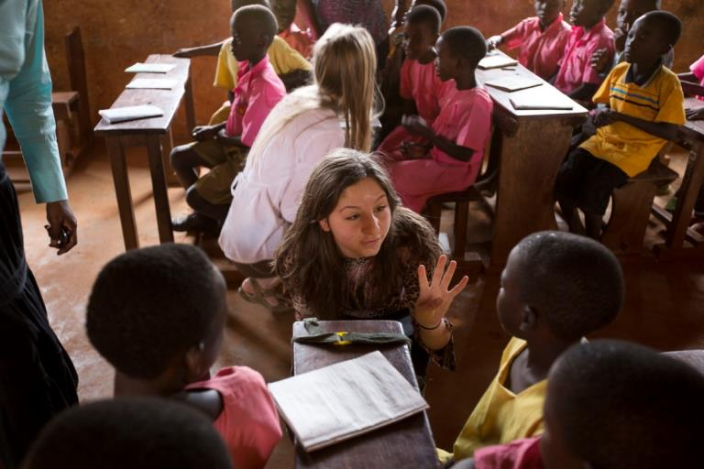
Maisie: We heard about a number of barriers preventing some children with disabilities from getting an education. But, there are grounds for optimism – firstly because there are a number of successes… Bishop Willis primary school is a phenomenal example of inclusive education and equality in Uganda, and the Ministry of Education have new policies that promise to overcome many of these barriers. And finally, having met some inspiring campaigners, we know they will campaign tirelessly until policy is put into practice in Uganda.
It is children like Peter at Bishop Willis School who made me want to become an Ambassador for the Send My Friend to School campaign. This trip confirms to me that the biggest global waste of all is the loss of potential. But with help from Peter’s teachers he now has a great future. But what about the other children who’s potential is not being realised? We must act.

Rebecca: I loved every moment of being in Uganda. The faces of the people we met linger in my mind, and will do for years to come. I was overcome by the positive attitude of many with disabilities, and came back inspired. I fully support the system of Inclusive Education, as with my own visual impairment I personally could not bear to have any other type of education. Inclusive education offers mutual understanding and removal of any potential stigma attached to special needs. We need to realize that there are millions out of education with no hope of an exciting life, and full of challenges ahead of them simply because they have a disability.
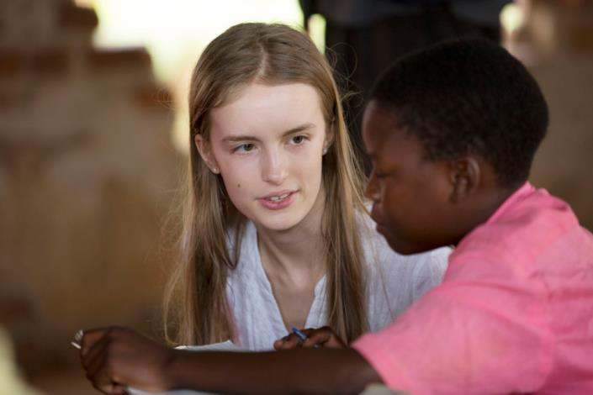
I feel strongly that people should be more aware of how important it is for all children across the world to fulfil their right to an education – we can all play a part in campaigning for that right.

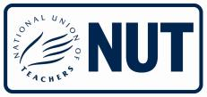
With special thanks to:

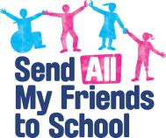

Photos: © Graeme Robertson/GCE UK
This project is funded
by the European Union.

