Sam Whittingham and Millie Wells, Young Ambassadors 2013
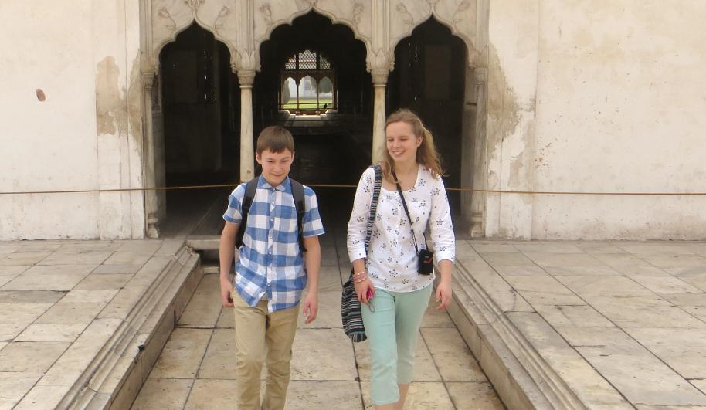
A Diary from India
Sam Whittingham and Millie Wells from Ringwood School in Hampshire are this year’s Young Ambassadors. They have just returned from India where they investigated why so many children are not receiving the quality of education they deserve. They heard from loads of young people about the challenges they face, and ended the week by speaking out to local politicians at a public hearing on behalf of the children they had met.
Here is their diary …
Day 1 - Monday 18 February
On our first day in Delhi we visited an urban slum settlement called Trilockpuri. During the journey the first thing that hit us was the number of people and the sheer bustle of the area as we saw many children working on the streets and building sites who really should have been in school.
Meeting schoolchildren in the slums of Delhi
At the Joint Organisation for Self Help (JOSH) project we talked to many students to gain their feelings and impressions of their school life. The students at the Minority Resource Centre (MRC) really wanted better teachers and more of them; they explained that sometimes there can be 60, 70 and in some cases 80 students per teacher, even though the Right To Education (RTE) Act 2009 clearly states that there should be a teacher pupil ratio of 1:35. Added to this Simmi told us that sometimes there can be one teacher covering 2 classes, which meant they could be in control and in charge of up to 160 students. We found this totally shocking, as it is so completely different to back in England.
We understood that there was a lack of resources and facilities; Rukxsar told us there could be 4 children at a 1 person desk, and classrooms were very small; Gulashan had never used the toilets in school because they were either utterly disgusting or there were no toilets open, as the only one was locked for teacher use. Although the RTE is very specific about school hygiene and sanitation, in many places these criteria are not being met. Some students sadly refused to use a school toilet all day. This is, in our mind, completely unacceptable; it is just not good enough that students don’t get the same opportunities to succeed that we have in England.
All students suggested how they would like to improve the education system in India, for example Simmi wished for more, and better qualified, teachers and Julista wanted access to newer subjects like dance and music as well as sport.
Although most people we spoke to wanted improvements, they all really valued the opportunity to go to school and learn and were desperate for a good education. Many even wanted to go on and become a teacher themselves despite their own poor education. Again this is hugely different to students’ experience in many English schools. We are sure that the next generation is determined that all children should receive a good education and will lift themselves out of poverty. What an illuminating day!

Day 2 - Tuesday 19 February
We travelled through the bustling traffic of Delhi to Madanpura Khadar, an urban resettlement colony. The road became very uneven and muddy, presenting a real challenge to our driver.
We met with Alok, the Progamme Manager for EPRAH - Empowerment For Rehabilitation, Academic and Health - a project funded by Oxfam. Alok discussed the astonishing dropout rates for girls; 50% for year 5 and then as high as 70% at year 10. We heard that this resettlement colony is divided up into housing plots and were shocked by their sizes. The smallest provided only 12 square metres for families of up to 5 plus children. 95% of these families have no toilet. The small size of people’s home shocked us.
We learnt that we were to visit the least funded type of school, run by the local authority. There are 1792 of these in Delhi. We arrived at Madanpura Khadar Primary School and joined a Year 5 class where the children were learning mathematics. The topic was complex. We were surprised that they were calculating areas of rectangles and triangles in year 5!
The children were highly engaged and clearly enjoyed themselves. However some were unable to complete the questions because they got no teacher attention. Millie sat next to a girl with a two-year old brother. He was fast asleep next to her and she explained that she had to bring him to school as her mother was working. Millie found this utterly incomprehensible. How can someone learn with their baby brother next to them?
At the end of the school shift all 2,500 children – those from the junior and the secondary school - wanted to leave at exactly the same time. We felt mobbed as everybody wanted our autographs and contact details.
Listening to the girls
After lunch we met with the adolescent girls awareness group run by EFRAH. The group was set up to allow girls with two different problems; the first was dropping out of school because of family problems including poverty, the other concerned sexual harassment. The group clearly empowered the girls who often spoke with great confidence.
One tragic story concerns a girl who didn’t want us to use her name. This is her story. From Year 6 onwards, boys followed and taunted her and her life was made a misery on her way home from school. However, her parents blamed her and would not let her attend school. Their pride meant they didn’t want the family reputation tainted. At 16 years old she is to have an arranged marriage she doesn’t want. It is doubtful whether she will return to education. This story hit us hard; it was an intensely emotional experience. Unfortunately this situation is a reality for many Indian girls and other stories were equally powerful.
Making teacher puppets
While Millie chatted with the girls, others made ‘Send My Friend’ puppets with Sam. They were asked to write what they thought made an ideal teacher on the puppets. They said teachers needed to talk to children as part of their lessons and should ensure that the students understood the work before moving on. Pinky, Sonam, Jyoti, Priyesh, Anu, Drurga and Shivani all wished teachers would turn up on time and they complained about their huge class sizes (up to 80).
We ended the day with feeling that English students take so much for granted and we wish that they could all share this experience.

Day 3 – Wednesday 20 February
For the past two days we have spent our time in slum communities, we’ve heard from young people their grievances about their school life and how they envisaged an ideal school and teacher. Today we had the chance to speak to senior officials from the AIPTF, the All India Primary Teachers’ Federation, and the coordinator of the NCE, the National Coalition for Education, the Global Campaign for Education in India.
We posed questions relating to the individual stories that we have heard and asked them how and why we’d seen such poor, uncommitted teaching as well as the unfurnished classrooms and below basic equipment in school. They agreed with what we told them about the standard of teaching being frequently quite poor and said that they wanted all teachers to be full time and fully trained. At the moment there are many unqualified and semi-qualified parent teachers and part-time teachers who only work for around 11 months and then have their contract stopped. They also said that teachers need proper training, as at the moment, anybody could become a teacher instantly as there are few set standards or training requirements. This is especially the case in private schools.
Learning about teachers
We also discussed teachers’ salaries as we have been told about teachers not being in class as they had ‘other work’. The teachers’ union said a starting salary for a teacher is around 30,000 rupees in Delhi and 25,000 in other states. This is about £400 a month as opposed to around £2,000 per month in the UK. As this is quite a good salary in Delhi, we couldn’t understand why teachers could be absent and skipping class. Mr Rama Kant Rai told us that teachers are frequently assigned non-teaching roles by the government like counting trees, animals or doing the census which they have to accept as part of their contracts. This partly explained why so many children had talked about teacher absences. Using teachers for such jobs just deprives the children, who are the future of the country, of many days of valuable education every year.
Finally we got an overwhelming sense that the AIPTF and the NCE had the same view as us and agreed that teaching in India is not perfect and in some areas was very poor, but at the same time there are many teachers who are very committed and enthusiastic about helping their children.
We were invited by the AIPTF and NCE to visit another local authority school. This was hugely different to the school from the previous day; it had much better facilities, cheerful displays, friendly teachers and more classrooms. Furthermore, it was set in pleasant gardens! This was an eye-opener and really revealed to us the lack of equality between schools that are covered by the same government programme. This deficit occurs because of the location of schools such as the one we visited yesterday, as resettlement colonies suffer inadequate public services.

Young motivators
In the afternoon we met with the YP Foundation, a youth activism organisation. Here they work with peer educators between the ages of 18 and 21 to teach children from urban slum settlements life skills that help increase their memory, concentration and health awareness. Added to this, the project helps people to gain documents and identification so that they can register for school, and for the 25% of reserved places for children from poorer areas. We talked to two of the peer educators, Niharika, 18 and Raghav, 18, our talk with these two passionate young adults was truly inspirational who were doing a brilliant job with the children of poor urban communities. They were intelligent, politically aware and well connected, gaining sponsorship and grants wherever possible.
After meeting Niharika and Raghav we were taken to a slum community where YP volunteers worked and interacted with the children. We discussed the problems children face on a daily basis to get to school. For instance, they had to walk for about 45 minutes, as they couldn’t afford the school bus. There was certainly no financial support for families.
We spoke to one of the children’s parents who explained that she had a child with a disability. She went on to explain that her child was only allowed to go to school one day a week. We couldn’t comprehend how unfair this is. In Britain everybody has an equal chance for an education and anybody with disabilities would be welcomed to school. We wished things could be different, but at least it is a starting point, and one that the family, with the help of the YP Foundation, can build on to increase the time that the child will spend in school.
Day 4 – Thursday 21 February
Today we revisited Madanpur Khadar and had a meeting with Mr Vidyarthi, a member of the Delhi Committee on Protection of Child Rights. This committee looks into complaints related to such matters as child justice, health, education, HIV and AIDS.
We had the opportunity to raise questions such as the issue of failing schools, and in particular, private schools and whether to close or keep these schools open. Mr Vidyarthi didn’t state his final view but implied that he thought they should be kept open. In private schools, there are no policies to manage and monitor the standard of teaching in relation to the RTE. When we asked about class sizes and lack of sanitation in schools, Mr Vidyarthi stated that “The child can’t wait for tomorrow.” He seemed sympathetic to the cause and then said that class sizes improved in schools with increasing child age. Sam then asked him directly, “Do class sizes drop only because girls drop out increasingly after grade 5?”. He responded by saying this was probably so. This fascinating meeting taught us a great deal.
Giving evidence at a public hearing
We were invited to a public hearing, which happens once a year. Here the community put forward their complaints and the improvements they want to see in their community. When we arrived many had already gathered for the event. The complaints on the agenda included one from Anita, 16 years old, who complained about problems with class sizes, and dreadful insanitary conditions. Other complaints included women worried about security, health and lack of support for extremely needy relatives, and concerns over sexual harassment. We were struck by their strength and courage. Although often uneducated these women were really articulate.
We were both called as witnesses to give evidence at the public hearing about what we had observed in schools over the last few days. We felt extremely privileged to have been invited to do this. The public hearing was truly motivating for both of us as it gave us a chance to hear these passionate and articulate people and to mount some form of plea on their behalf.
The day concluded on meeting Anita again and having the opportunity to learn even more of her experience and develop a strong friendship.

Day 5 - Friday 22 February
Today we had the opportunity to take time out, do a little sightseeing and reflect on our experiences of the past week. We visited Red Fort, a grand red sandstone fort that demonstrated the power of the Mogul Empire. There were spacious grounds with beautiful buildings and many visiting tourists. This was a very different world from the resettlement colonies and slum communities. We also filmed nearby in the beautiful Lodhi Gardens, an almost secret retreat with sweeping lawns and old buildings of grand style and history. It too felt very distant from the slums of Trilokpuri and Madanpur Khadar.
This week has been an extraordinary eye opener. We have learnt and gained so much knowledge and understanding. The extreme poverty was a shock to us and really showed that where you are born or live dictates the chances you have in life.
Campaigning for the right to education
If the Indian government spent the targeted amount of GDP on schooling then the level of education would most definitely improve. All the country needs is the political will to drive forward better education for all. The government not only needs to allocate more money to education, but it also needs to fairly distribute the money for all children. A similar observation applies across the world. Every child can receive a good education if the political will is there and the needs of the poorest are not overlooked.
We now more clearly understand the part that the younger generation can play in campaigning for the right to education. All the people we have met have been so inspirational. The young, articulate school students, such as those we met at Trilokpuri and at the YP Project, were passionate advocates for the education of others. Those in the slums were desperate to promote their own need for education and for the infrastructure that allows it. This was the key message of the public hearing, where the community stated their grievances about the poor quality of their schools and demanded action.
From this experience we firmly believe we can both campaign more effectively for education. We are armed with an amazing real life experience of both the barriers to education and the ways communities can take action to make the government stick to their promises. We look forward to linking up with young people in the UK and our new friends in India to help make education for all a reality.
We feel fortunate and privileged that we had the opportunity that few others get and thank GCE UK, the NUT, Oxfam India and Oxfam GB for giving us this once in a lifetime opportunity.

