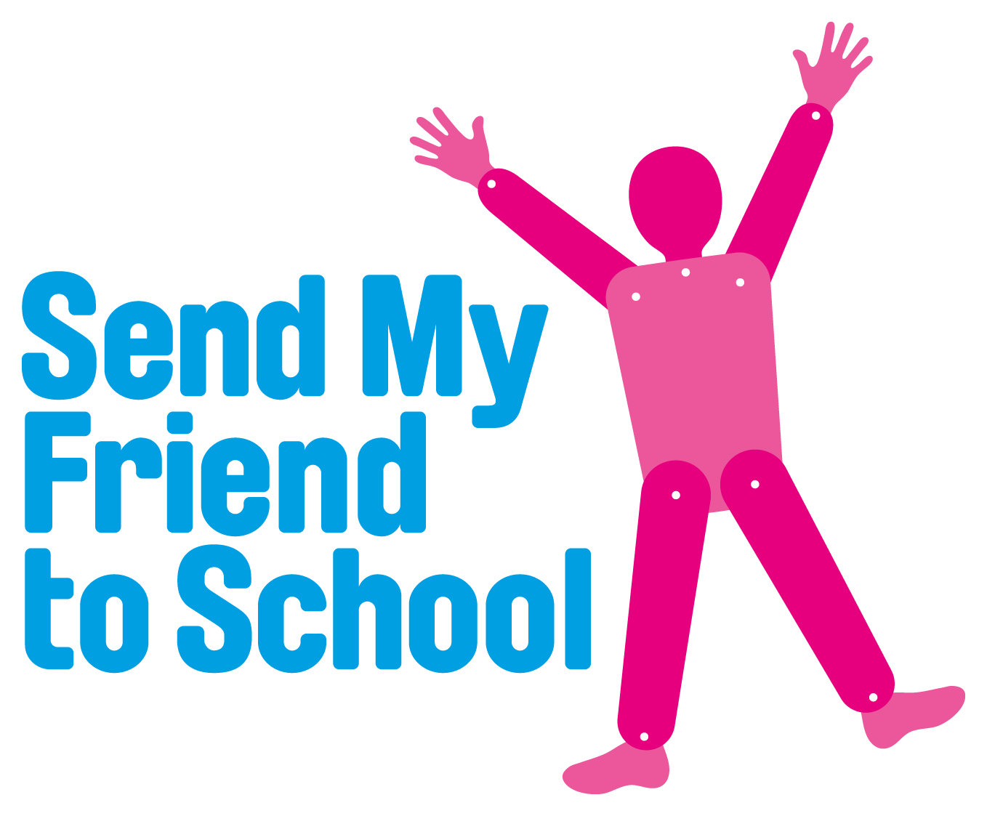

THE STEVE SINNOTT AWARD 2014
Young Ambassadors for the Global Campaign for Education

Wanted: Young education campaigners for a fact-finding mission!

The Global Campaign for Education
In the year 2000, as part of the Millennium Development Goals, world leaders promised that every child in the world would complete a quality, primary education by 2015. At this point it was estimated that over 100 million children were missing out on school and many more were dropping out before completing even a primary education.

The Global Campaign for Education (GCE) – a coalition of international aid agencies, teachers unions and civil rights groups was formed to remind and hold world leaders to this promise. This network is now active in over 100 countries.

The campaign theme for 2014 is disability and inclusion – more than a third of all the children missing out on school around the world have a disability. Our 2014 campaign aims to highlight this issue and make sure that no child is forgotten!

Steve Sinnott
Steve Sinnott, who sadly and suddenly died in 2008, was a passionate advocate for Education for All. During his time as General Secretary of the NUT he was a committed member of the Global Campaign for Education (GCE), which believes that education is the route out of poverty. The Award is funded in his memory.

The Award Scheme
Year 10 students (14-15 year–olds) in the UK are invited to apply through their school for the Steve Sinnott Award which will give two committed individuals, and their teacher, the amazing opportunity to travel out to the developing world and investigate the barriers to education there.

This award is open to all secondary schools and we are keen to encourage applications where one or both of the candidates have a special educational need or disability.

On return, the UK young campaigners will have a chance to get involved in the campaign in 2014 by:

- Presenting the campaign for students in schools around the UK who take part in Send My Friend to School
- Speaking directly to MPs and Ministers and in public meetings
- Presenting their findings to the NUT conference and at other events
- Blogging and writing articles for the media including the Send My Friend website, youth media and other requests
The trip in 2014
This year the trip will be hosted by the charity Sightsavers and will be to Uganda, in East Africa during February/March 2014.

Sightsavers is a registered UK charity, working in more than 30 developing countries to prevent blindness, restore sight and advocate for social inclusion and equal rights for people with disabilities. Sightsavers believes that getting a quality education is crucial to lifting people out of poverty. It works to make sure children who are blind or visually impaired, and children with other disabilities, get the chance to go to school, receive a quality education, and reach their full potential.

Please note: if one or more candidates has a special educational need or disability Sightsavers and the Global Campaign for Education can offer additional support. For instance, we could provide extra mentoring support, or we could pay for the travel and accommodation costs of a carer accompanying the group to Uganda.

Please supply details of any anticipated extra support that would be required for the trip (and afterwards) as part of your application. Please note that the Uganda trip will involve a long flight and overnight travel to a rural area.

If you have any queries relating to this issue please email Sightsavers: schools@sightsavers.org

Why Uganda?

- The challenges faced by education providers in Uganda are similar to the challenges faced by education providers in other low-income countries, so the young ambassadors can apply what they learn in Uganda to other countries.
- Sightsavers has a well-established presence in Uganda, so can confidently facilitate the visit of the campaigners and ensure they have the opportunity to meet local stakeholders.
- There is a strong disabled people’s movement in Uganda, so the campaigners will have the opportunity to meet articulate, knowledgeable people with disabilities.
- Uganda also has the advantage of having direct flights from London (or one stop) with flight duration of around 8 – 12 hours.
On arrival in Kampala the Young Ambassadors will meet with policy makers and campaigners to hear about the challenges to education in the country and what is being done towards progress. They will then travel to Iganga, a 3 hour drive from Kampala, where they will meet with children who are missing out on school due to discrimination or barriers to education for those with disabilities.

They will also visit the Uganda Inclusive Education Programme, which aims to increase enrolment of blind and low vision children in Uganda by 25 per cent by 2016. The young ambassadors will be able to find out about the project, where Sightsavers provides equipment, assistive devices, braille machines and paper and also provides training for teachers in special needs education.

While there, they will meet with children with disabilities and teachers at the school to find out about their experience of education, the difference it makes to the lives, and the barriers they have to overcome. During the trip they will also meet with local and national politicians.
How to apply:

All 4 requirements below must be completed for a school to be considered for this award.

Students to supply the following:

- Two named students (selected by the teacher) to produce a joint presentation (this could be a film, audio presentation or slide show).

Please note that if you supply a film this should be in one of the following formats: .wmv, .mov, .mp4

This presentation must include:
- an illustration of how their school has been involved in the Send My Friend to School campaign this year
- details of what personal skills they would bring to the fact-finding mission overseas and their role as Ambassadors in speaking to media, their peers and politicians on their return.
- an explanation of why they feel passionate about this issue and why they would like to be the Young Ambassadors for the Global Campaign for Education 2013.

2. Students to submit some written work in the form of a short article or blog explaining why they have entered the competition and what it would mean for them personally (max 200 words).

The supporting teacher to supply:

3. As this is an opportunity of a life-time, we would like the teacher to submit 200 words on each student explaining why they have been chosen and how they feel the student could benefit from this opportunity.

4. The entry form (below) with all details must be completed and returned with the above applications, no later than 15th November 2013.

We would prefer all entries to be submitted via email, but our postal address is included below as well:

Email for applications and queries: schools@sightsavers.org

Postal address for applications:
Sarah Nelson
Sightsavers
Grosvenor Hall
Bolnore Road
Haywards Heath
West Sussex, RH16 4BX
Terms and conditions:

UK school students aged 14-15 (applicants should be starting Year 10 in September 2013)

Two named students from each school are eligible to apply, ideally a boy and a girl, but all entrants will be considered.

Shortlisted applicants will need to be available to do a presentation to the judging panel in central London in December 2013.

The winners and an accompanying teacher will be required to travel to a developing country in February/March 2014 and be able to miss up to one week of school.

The winners will also be required to give some time to supporting the campaign during 2014; by speaking at events, doing media interviews and meeting politicians.

Students and their teacher will need to be able to travel.

The closing date is 15 November 2013.

Preference will be given to schools and students who have been very active in the Send My Friend campaign in the past.

The judges’ decision is final.

The Steve Sinnott Award
Young Ambassadors for the Global Campaign for Education 2014

Entry form

School Contact Details

Name of School:……………………………………………………….

Background information: (type of school, size, % free school meals)

…………………………………………………………………………….

…………………………………………………………………………….

…………………………………………………………………………….

Address: ……………………………………………………………….

…………………………………………………………………………….

…………………………………………………………………………….

School telephone number.……………………………………………

Teacher Contact Details

Teacher’s Name: ………………………………………………………

Title: ……………………………………………………………………..

Teacher’s email address: ………………………………………….

Teacher’s mobile phone no: ……………………………………….

Student applicants

Name 1: ………………………………… Age: ……………… Sex: ……..

Name 2: ……………………………….. Age: ………………. Sex: ……..

If your students have any special requirements please tick this box and
attach further details.

